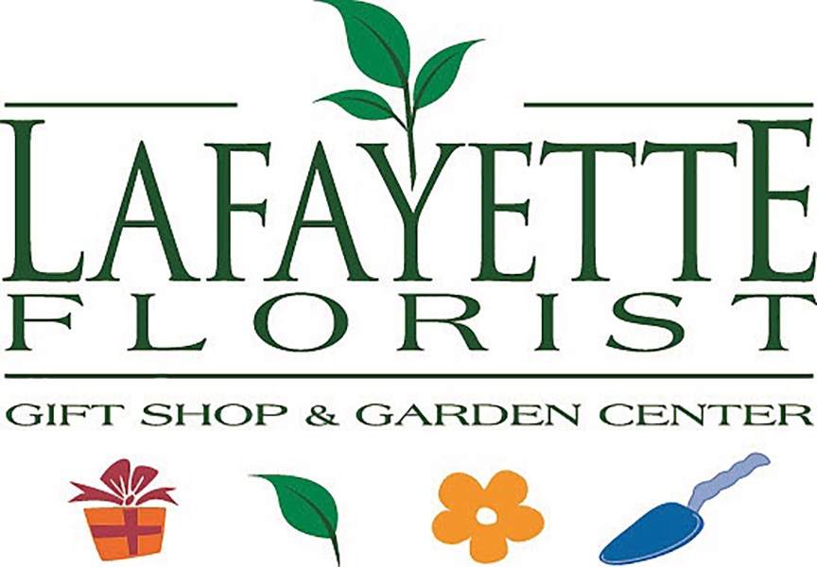

How to prepare for your flower wedding consultation

There are so many decisions to make when planning a wedding. When it comes to flowers it can be a little daunting. What are the best flowers to use? What style do you like? How can I make it special and customized? Our wedding consultants will guide you through the process, but here are a few tips to make it run smoothly.
Consultation Prep tips:
- Look at lots of pictures and clip them. Create a Pinterest page of all your favorites. Make a list of what you like about that bouquet. Is it the color, the shape or a flower that is intriguing. Watch for common denominators in your choices. (If you’re not into Pinterest or Instagram – no worries, we have lots of pictures to show you).
- Bring color swatches. We can match ribbons and flower varieties and offer suggestions of blending shades.
- Don’t worry about flower varieties or too many details. That’s where we can help you create the vision.
This is a fun process. Don’t fret. We listen, we care and we want to make your day extra special with flowers.

Wedding Consultation Questionnaire:
Contact Information
Name of Bride & Groom

Bride & Groom phone number
Bride & Groom Emails
Name of Planner (if applicable)
Name of Photographer
We LOVE getting photos of your special day. Would you be willing to share your photos with us or let us contact your photographer for photos?

Wedding Information
Ceremony Location & Address
Date/Time
Reception Location & Address

Wedding Colors
Color(s) & Styles of
- Bride’s Dress
- Bridesmaids
- Groom
- Groomsmen
- Reception tables & linens
Are there any known allergies to certain types of flowers?
What is your approximate floral budget?
What would you consider your theme or style of wedding to be?
(ex. Bohemian, Traditional, Rustic, Elegant, etc.)
Are there any flowers you MUST have at your wedding?

Are there any flowers you DO NOT want in your wedding?

Below you can jot down all of your floral ideas in the Description box so we can create a custom proposal for you. Remember that the more information, the better! Let us know the quantity needed for each item in the Quantity box.
Items needed for your wedding flowers
Item | Description | Quantity
Bride
Bridesmaids
Junior Bridesmaids
This could be a corsage, flower crown, or small bouquet for a special young lady. She’s typically older than a flower girl and younger than a bridesmaid.

Toss Bouquet
A toss bouquet is a small bouquet about 15% of the size of the bridal bouquet. It’s a special tradition to throw the bouquet for your bridesmaids. Superstition says it will be caught by the bridesmaid next in line to get married!

Flower Crown
We can create a beautiful bridal floral or greenery crown or this can be a beautiful token for someone special at your wedding.
Groom Boutonniere

Groomsmen Boutonnieres
Junior Groomsmen boutonniere
He is typically older than a ring bearer and younger than a groomsman.

Mother of the Bride Corsage
Mother of the Groom Corsage
Father of the Bride Boutonniere
Father of the Groom Boutonniere
Grandparents of the Bride
Grandparents of the Groom
Officiant and/or musician boutonniere or corsage
Dog flower collar
Make sure your special pup is part of your big day. We can make a floral or greenery dog collar.
Any additional corsages & boutonnieres:
Additional may include: special friend or relative, photographer, wedding coordinator, someone who came from far away. Add names and we will label them.
Flower Girl(s)
She can’t be a flower girl without flowers! You can make her feel extra special with a flower crown or miniature wrist corsage along with her basket of rose petals
Ring Bearer Boutonniere
Ceremony Altar
Think of ways to make the altar extra special. This is where some of your favorite photos will come from so it’s important to have a beautiful altar. It can be floral arrangements, a floral piece representing someone who has passed, unity candle arrangement, foliage plants
Ceremony Archway

Ceremony Aisles
pew bows, garden planters, shepherds’ hooks with hanging floral vases
Reception flowers
Guest book table, gift table, flowers for card box, wine bar/ drink table, place card table, garlands
Guest Table Centerpieces
Bathrooms
Add a welcoming touch with a small floral piece by the sink.
Head Table/Sweetheart Table/Family Tables
Cake Flowers
This can be loose cuts inspired from your wedding bouquet for the cake decorator to apply or a professionally designed cake topper. You can place arrangements on this table as well.
Guest Party Favors
This is a great way to send guests off with a thank you token for celebrating your special day. This could be a small box of chocolates with a rose, a small plant or cactus, etc.
Extras
Do you need flowers by the bunch? If so, what flower varieties would you like bulk pricing for?

Do you need delivery and/or set-up?

